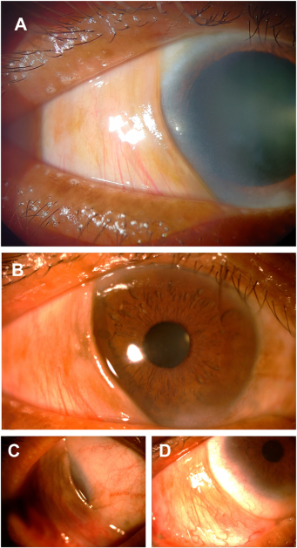

A 69-year-old man presented with a membrane over the bulbar conjunctiva in his right eye (OD), encroaching cornea from the temporalside, and freely movable over the conjunctival and corneal surface (A). Extraocular movements were free. The patient had no history ofpain, foreign body sensation, lacrimation, chronic illness, prior hospitalization, trauma, adverse drug reaction, or chemical injury. TheSchirmer’s test showed normal tear film production. The patient had cataracts in both eyes, otherwise, anterior segment and fundus findingswere normal. Uncorrected visual acuity was 6/36 OD and 6/18 in the left eye (OS). Intraocular pressure was 16 mmHg OD and 15 mmHgOS, respectively. Image of OD with membrane in (B) primary gaze, (C) down and out position, and (D) up and inwards.Based on the provided images and clinical description please make an ophthalmic diagnosis for this patient. And output the diagnostic conclusions only

**Pseudopterygium**